**Web Service**

A web service is any piece of software that makes itself available over the internet and uses a standardized XML messaging system. XML is used to encode all communications to a web service. For example, a client invokes a web service by sending an XML message, then waits for a corresponding XML response. As all communication is in XML, web services are not tied to any one operating system or programming language.

* **Architecture Overview:**
  + SOAP (is a messaging protocol specification for exchanging structured information in the implementation of web services in computer networks. Its purpose is to induce extensibility, neutrality and independence.)
  + WSDL (The Web Services Description Language is an XML-based interface definition language that is used for describing the functionality offered by a web service.)
  + UDDI (Universal Description, Discovery, and Integration) is an XML-based registry for businesses worldwide to list themselves on the Internet. Its ultimate goal is to streamline online transactions by enabling companies to find one another on the Web and make their systems interoperable for e-commerce.)

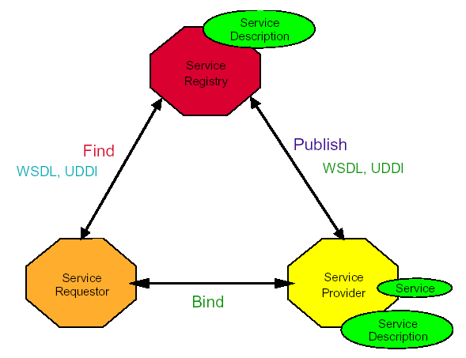

*Sample web service project:* **Arithmetic Test**

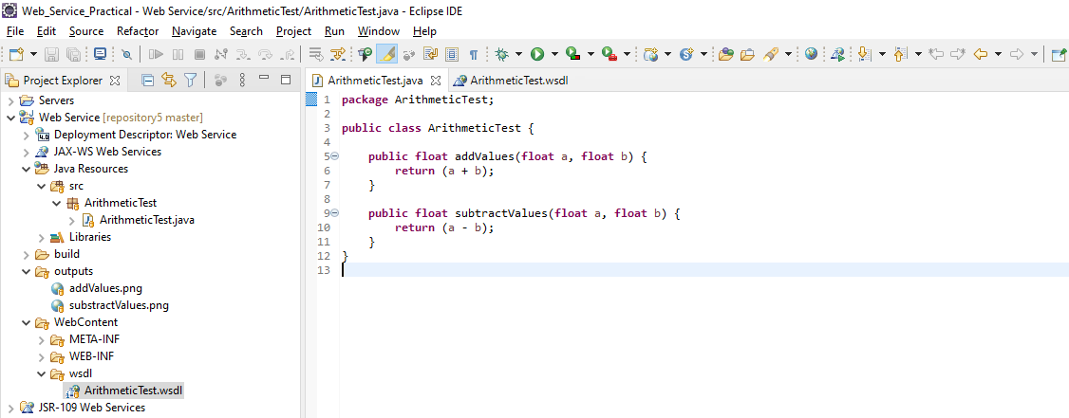

*Functionalities*:

1. addValues

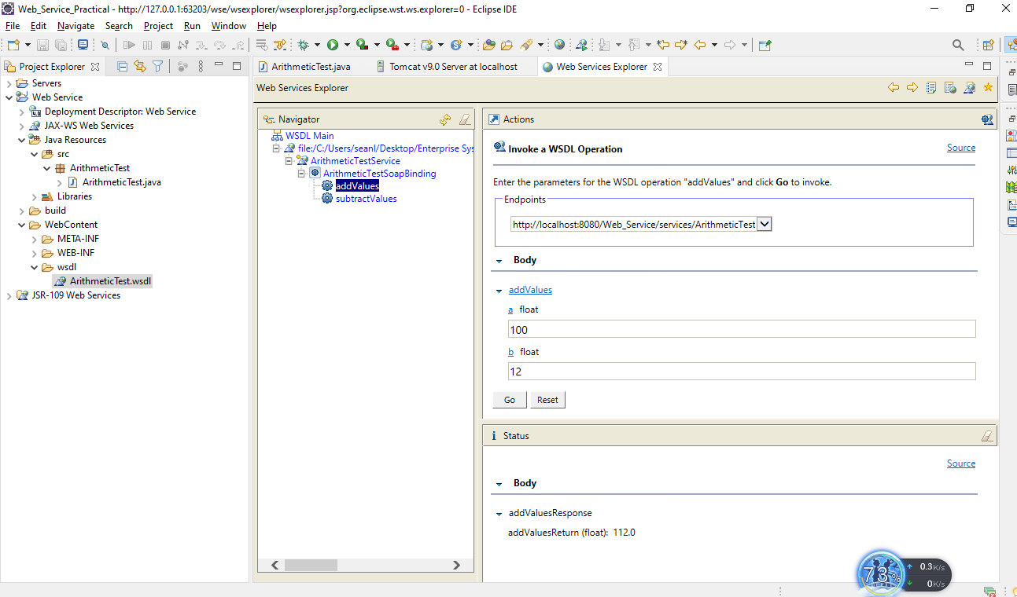

1. substractValues

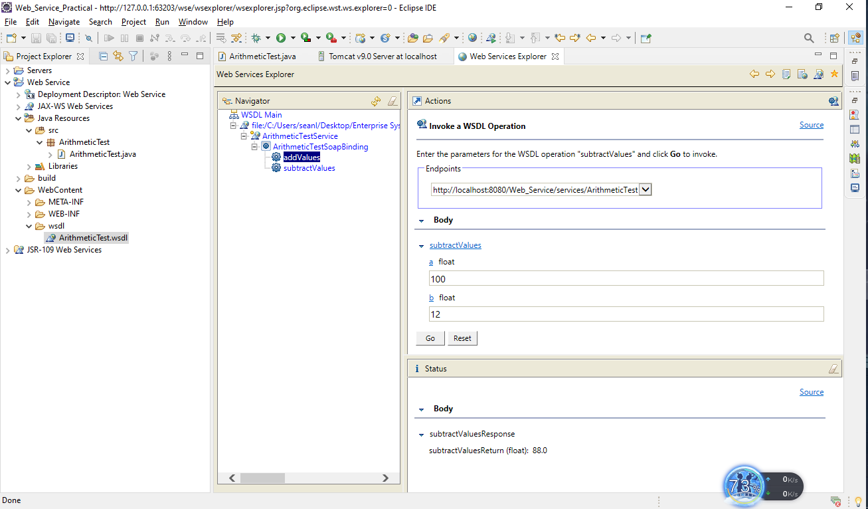

*Design:* ArithmeticTest.wsdl

